- Display all employees with their dept name.
SELECT e.ename, d.dname
FROM employee e
JOIN department d ON e.deptno = d.deptno;
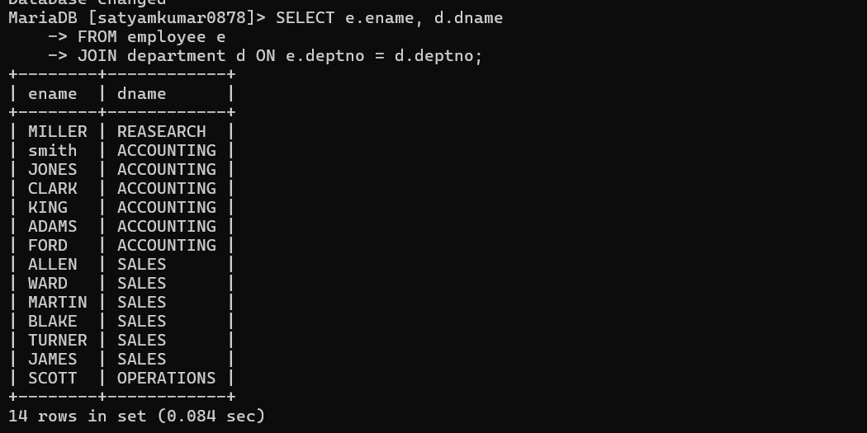
- Display those employees whose manager names is jones, and also display their manager name.
SELECT e.ename AS employee_name, m.ename AS manager_name
FROM employee e
JOIN employee m ON e.mgr = m.empno
WHERE m.ename = 'JONES';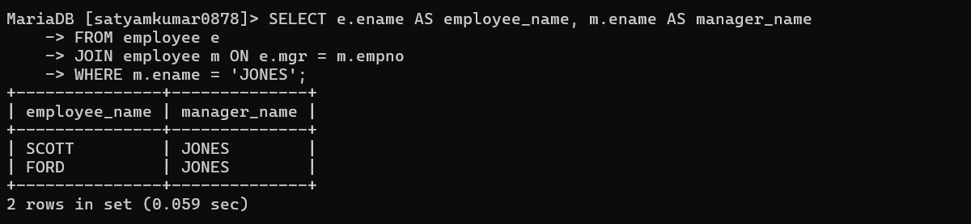
- Display employee name, his job, his dept name, his manager name, his grade and make out of an under department wise.
SELECT
e.ename,
e.job,
d.dname,
m.ename AS manager_name,
e.grade
FROM employee e
JOIN department d ON e.deptno = d.deptno
LEFT JOIN employee m ON e.mgr = m.empno
ORDER BY d.dname; 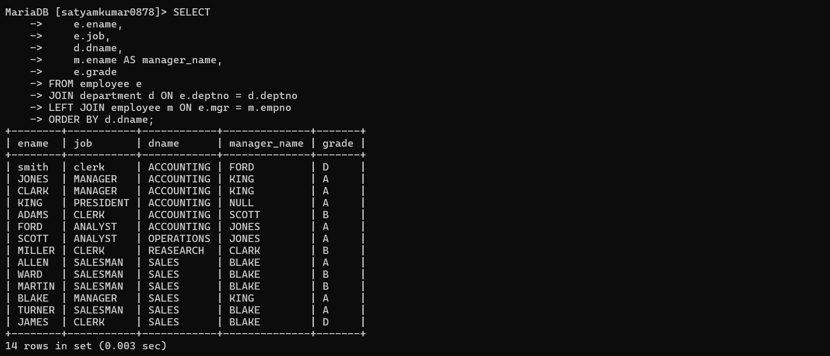
- List out all the employees name, job, and salary grade and department name for everyone in the company except ‘clerk’. Sort on salary display the highest salary.
SELECT
e.ename,
e.job,
e.grade,
d.dname,
e.sal
FROM employee e
JOIN department d ON e.deptno = d.deptno
WHERE e.job <> 'CLERK'
ORDER BY e.sal DESC;
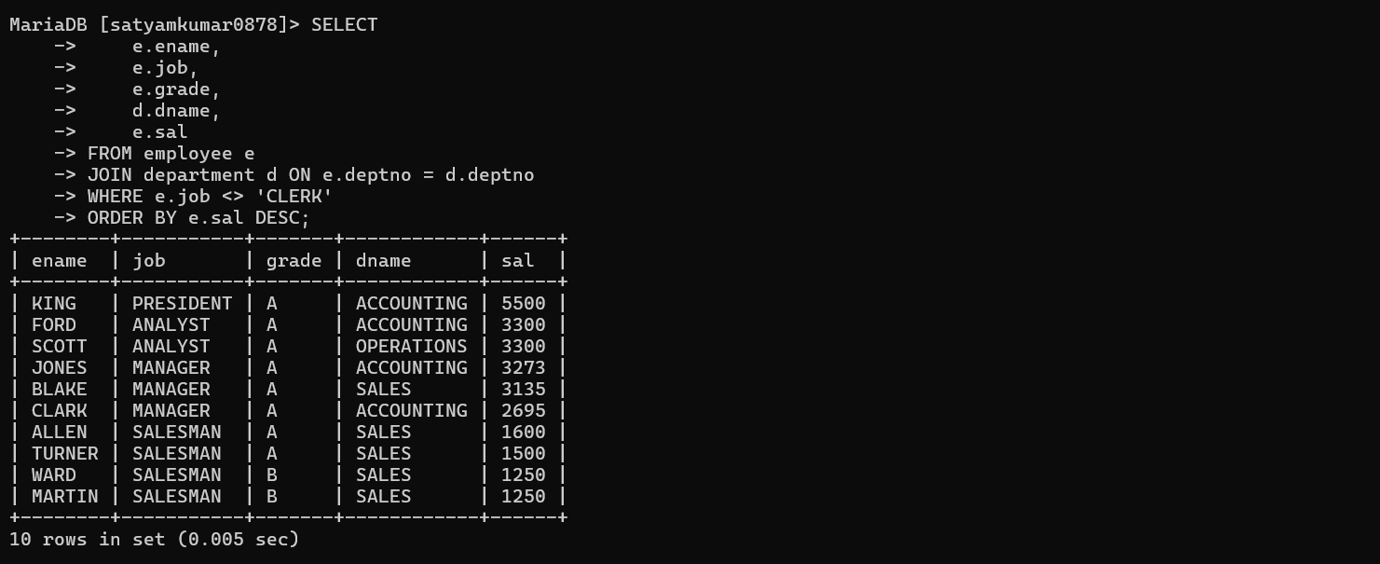
- Display employee name, his job and his manager. Display also employees who are without manager.
SELECT
e.ename,
e.job,
COALESCE(m.ename, 'NO MANAGER') AS manager_name
FROM employee e
LEFT JOIN employee m ON e.mgr = m.empno;
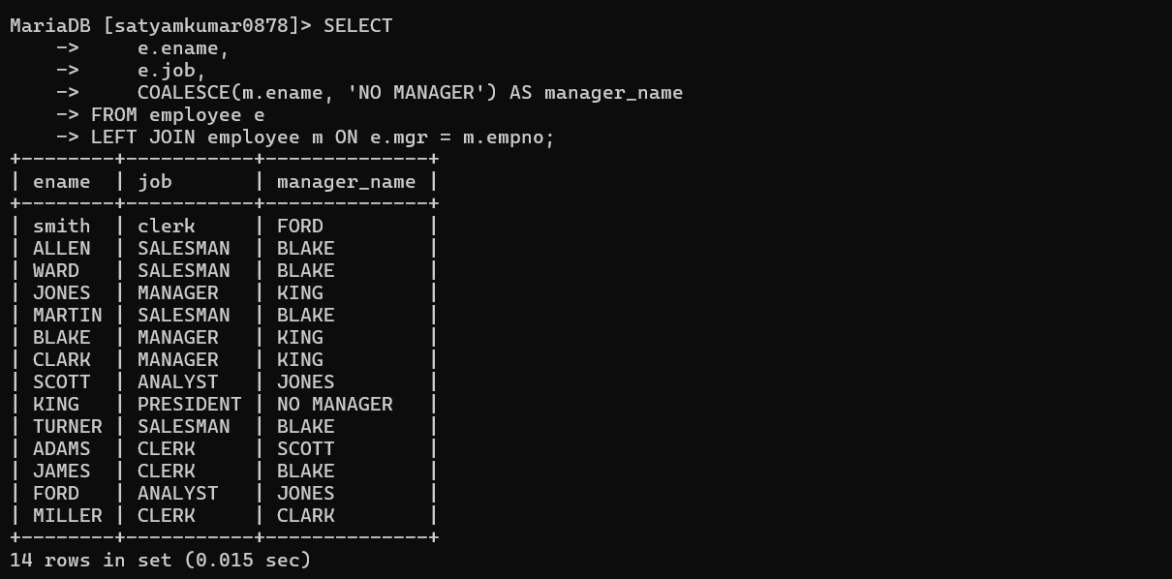
- List the employee name, job, annual salary, deptno, dept name and grade who earn 36000 a year or who are not clerks.
SELECT
e.ename,
e.job,
e.sal * 12 AS annual_salary,
e.deptno,
d.dname,
e.grade
FROM employee e
JOIN department d ON e.deptno = d.deptno
WHERE e.sal * 12 = 36000
OR e.job <> 'CLERK';
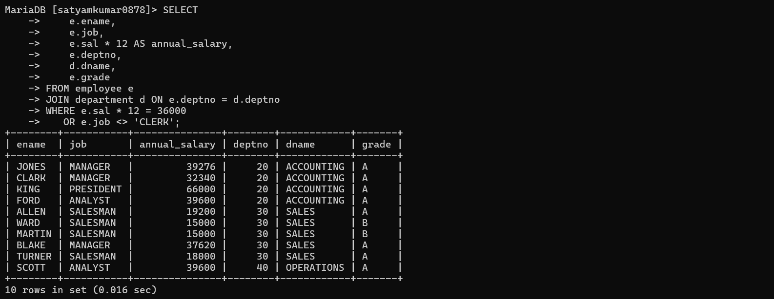
- List ename, job, annual sal, deptno, dname and grade who earn 30000 per year and who are not clerks.
SELECT
e.ename,
e.job,
e.sal * 12 AS annual_salary,
e.deptno,
d.dname,
e.grade
FROM employee e
JOIN department d ON e.deptno = d.deptno
WHERE e.sal * 12 = 30000
AND e.job <> 'CLERK';
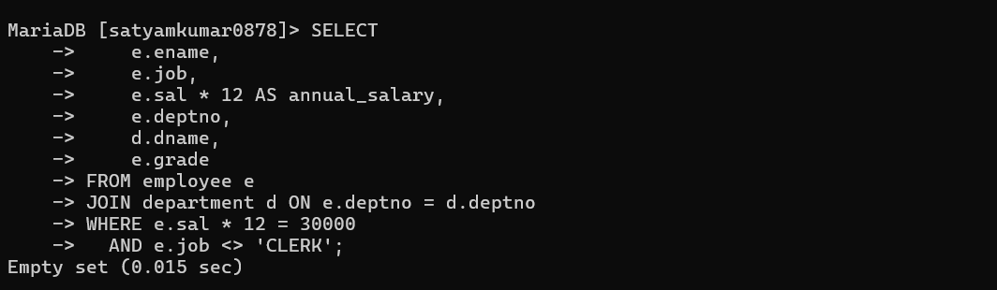
- List out all employees by name and number along with their manager’s name and number also display ‘no manager’ who has no manager.
SELECT
e.empno AS employee_no,
e.ename AS employee_name,
COALESCE(m.empno, 0) AS manager_no,
COALESCE(m.ename, 'NO MANAGER') AS manager_name
FROM employee e
LEFT JOIN employee m ON e.mgr = m.empno;
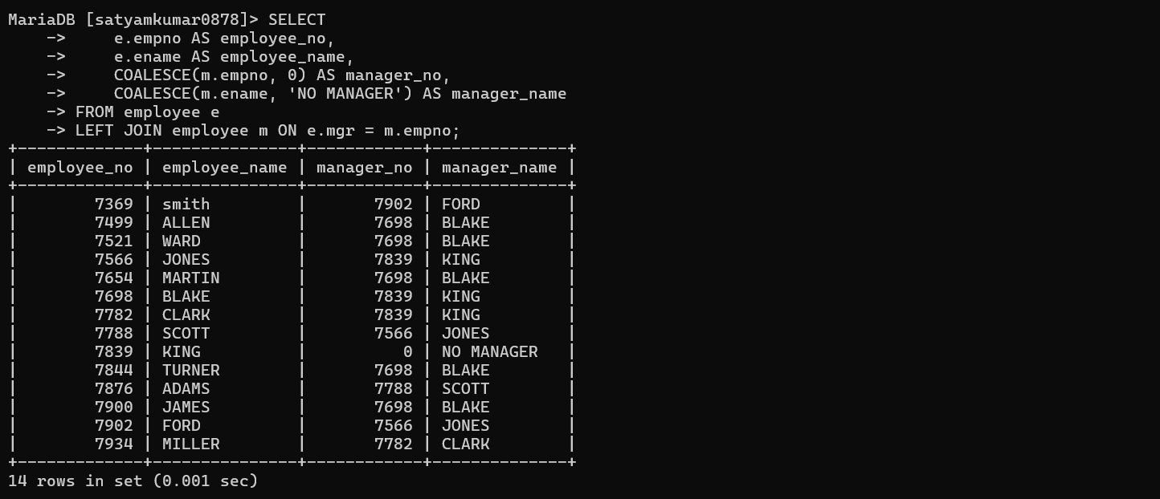
- Select dept name, dept no and sum of sal
SELECT
d.dname,
d.deptno,
SUM(e.sal) AS total_salary
FROM employee e
JOIN department d ON e.deptno = d.deptno
GROUP BY d.dname, d.deptno;
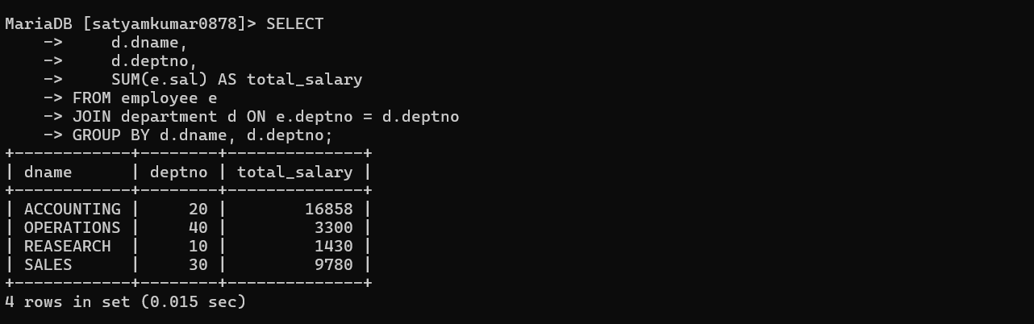10. Display employee number, name and location of the department in which he is working
SELECT
e.empno,
e.ename,
d.LOCATION
FROM employee e
JOIN department d ON e.deptno = d.deptno;
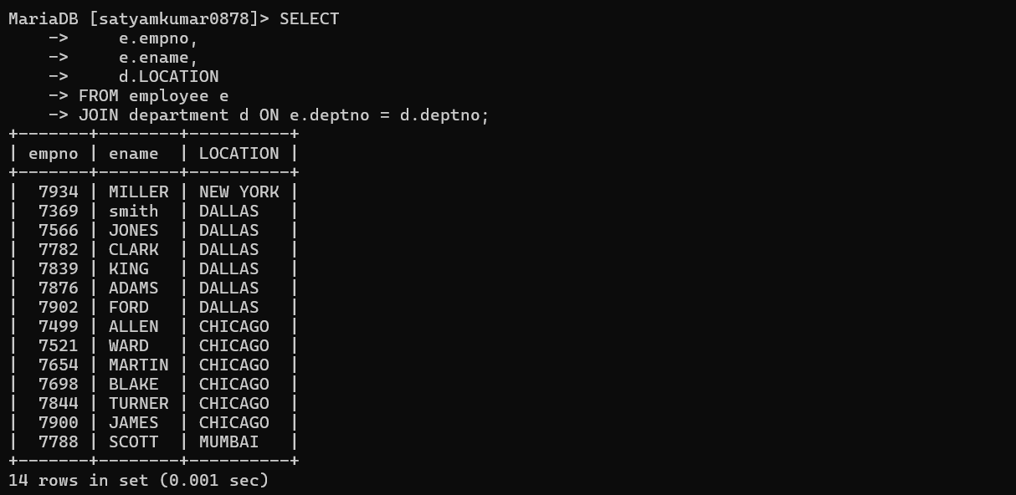
11.Display employee name and department name for each employee.
SELECT
e.ename,
d.dname
FROM employee e
JOIN department d ON e.deptno = d.deptno;
